**Junit Basic Testing**

**1.Setting Up Junit  
  
SimpleTest.java**import org.junit.jupiter.api.Test;  
import static org.junit.jupiter.api.Assertions.*assertEquals*;  
  
public class SimpleTest {  
  
 @Test  
 public void testAddition() {  
 int result = 2 + 3;  
 assertEquals(5, result);  
 }  
}  
  
  
**Junit Dependency**  
  
<dependencies><dependency>  
 <groupId>junit</groupId>  
 <artifactId>junit </artifactId>  
 <version>4.13.2</version>  
 <scope>test</scope>  
 </dependency>  
</dependencies>

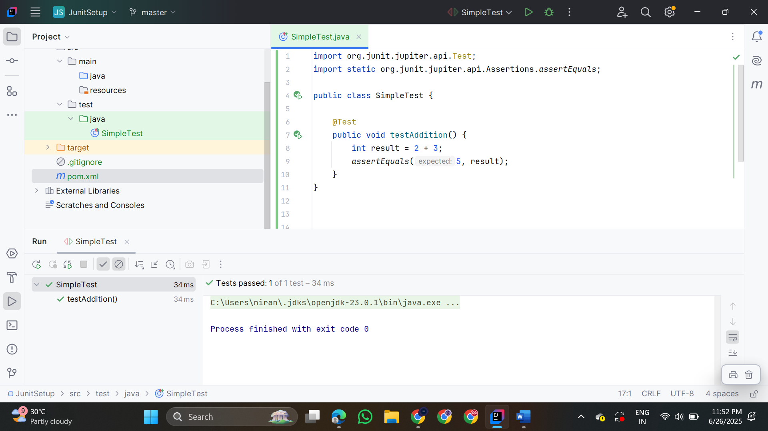

**2.Writing Basic Junit Tests**

**Calculator.java**

public class Calculator {

public int add(int a, int b) {

return a + b;

}

public int subtract(int a, int b) {

return a - b;

}

public int multiply(int a, int b) {

return a * b;

}

public int divide(int a, int b) {

if (b == 0) {

throw new IllegalArgumentException("Cannot divide by zero!");

}

return a / b;

}

}

**CalculatorTest.java**

import org.junit.jupiter.api.Test;

import static org.junit.jupiter.api.Assertions.*;

public class CalculatorTest {

Calculator calc = new Calculator();

@Test

void testAdd() {

assertEquals(5, calc.add(2, 3));

}

@Test

void testSubtract() {

assertEquals(1, calc.subtract(4, 3));

}

@Test

void testMultiply() {

assertEquals(6, calc.multiply(2, 3));

}

@Test

void testDivide() {

assertEquals(2, calc.divide(6, 3));

}

@Test

void testDivideByZero() {

Exception exception = assertThrows(IllegalArgumentException.class, () ->

{

calc.divide(5, 0);

});

assertEquals("Cannot divide by zero!", exception.getMessage());

}

}

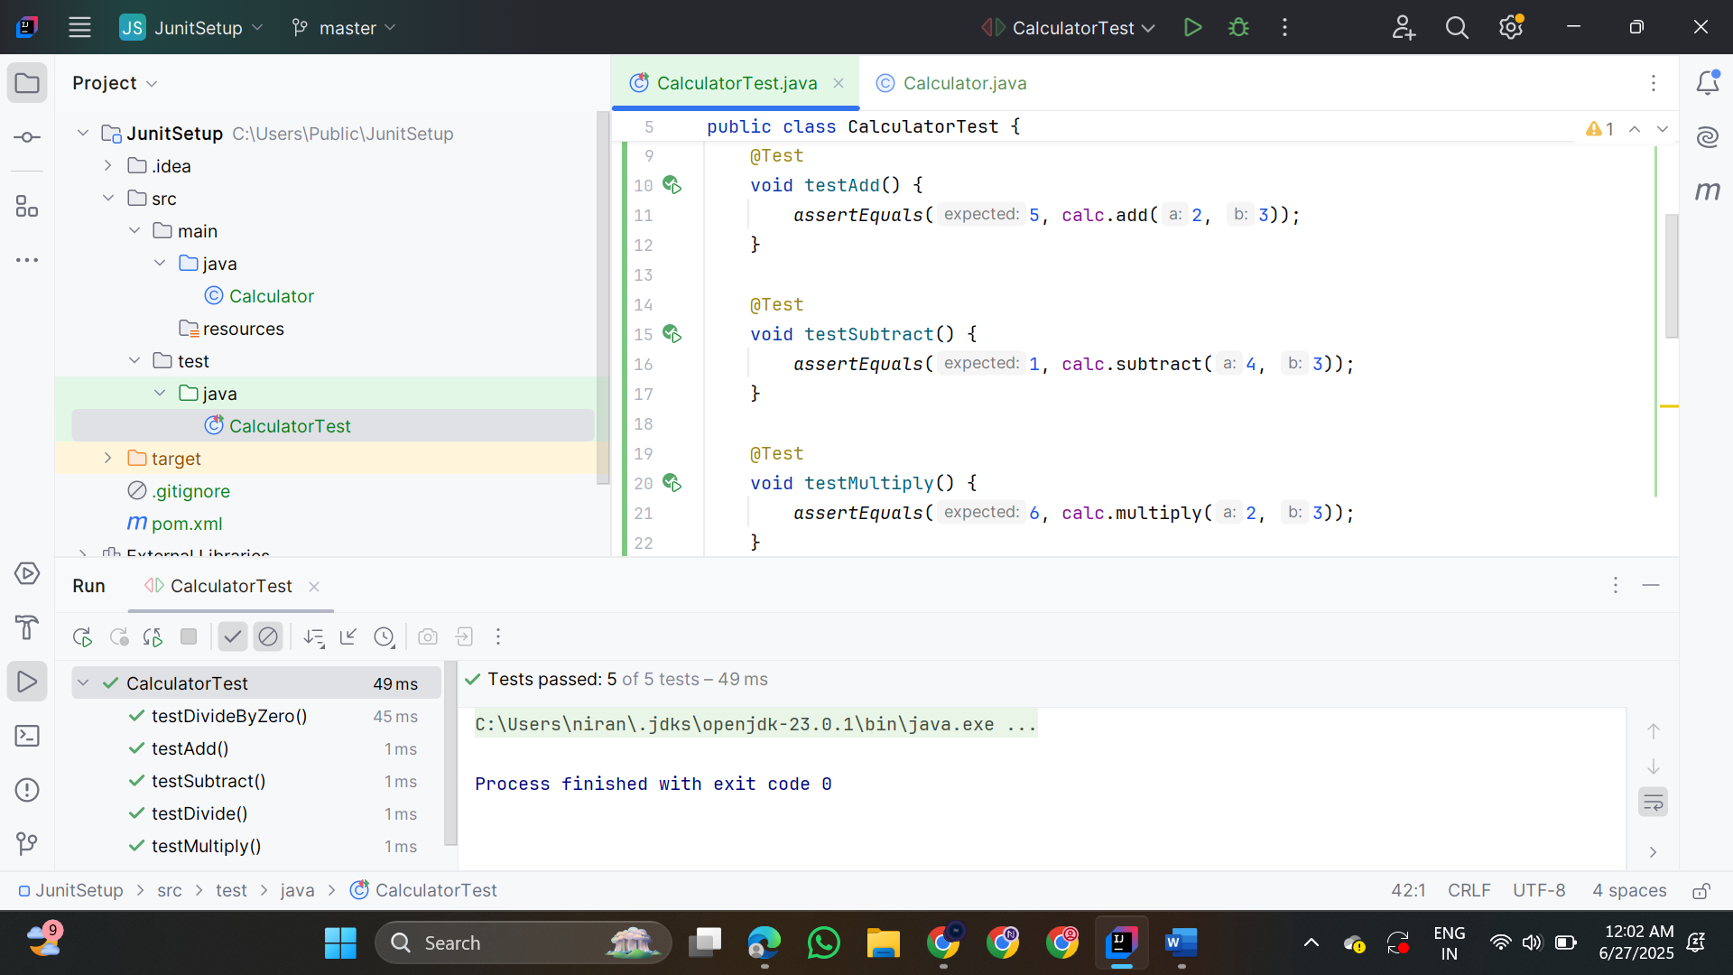

**3. Assertions in Junit**

**AssertionsTest.java**

import org.junit.jupiter.api.Test;

import static org.junit.jupiter.api.Assertions.*;

public class AssertionsTest {

@Test

public void testAssertions() {

assertEquals(5, 2 + 3);

assertTrue(5 > 3);

assertFalse(5 < 3);

Object obj1 = null;

assertNull(obj1);

Object obj2 = new Object();

assertNotNull(obj2);

}

}

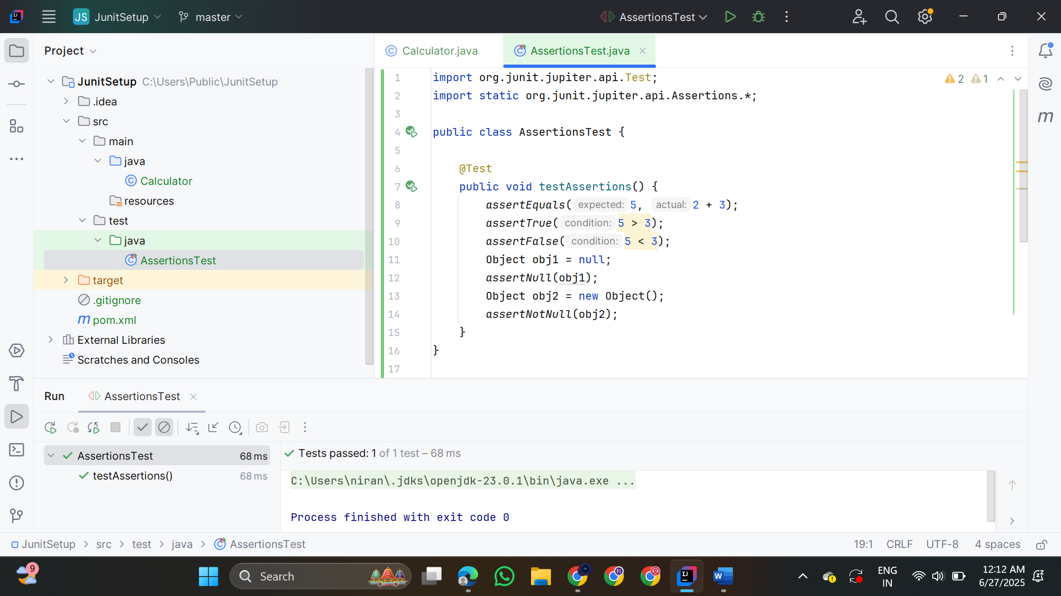

**4. Arrange-Act-Assert Pattern in JUnit**

**CalculatorAAATest.java**

import org.junit.jupiter.api.*;

import static org.junit.jupiter.api.Assertions.assertEquals;

public class CalculatorAAATest {

private Calculator calculator;

@BeforeEach

void setUp() {

System.out.println("Setting up Calculator...");

calculator = new Calculator();

}

@AfterEach

void tearDown() {

System.out.println("Tearing down...");

calculator = null;

}

@Test

void testAddition() {

int result = calculator.add(10, 5);

assertEquals(15, result);

}

@Test

void testSubtraction() {

int result = calculator.subtract(10, 4);

assertEquals(6, result);

}

}

